Memorandum of Understanding with
Varsha Bioscience And Technology India Private Limited, Hyderabad

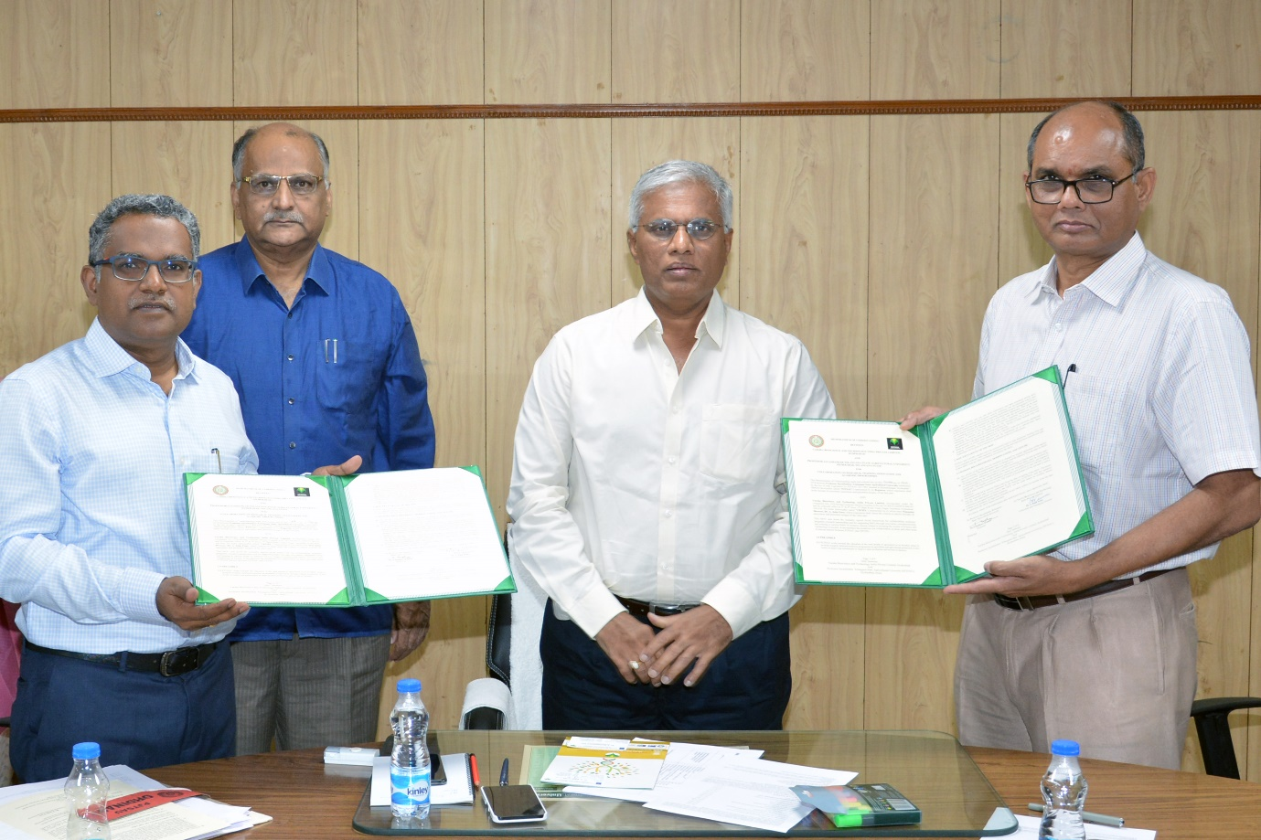

Dr.A.John Peter, Chairman and Managing Director, Varsha Bioscience and Technology India Private Limited, Saifabad, Hyderabad and Dr.S.Sudheer Kumar, Registrar Professor Jayashankar Telangana State Agricultural University, Hyderabad exchanging MoUs

- Create a Platform to conduct collaborative research projects for sustainable agriculture in the areas of common interest.
- Give hands on internship program to post graduate students on Skill development in the field of agriculture, IPM, INM and Organic Farming.
- Participate in sponsored research programs funded by International, National and State government agencies.
- Generate IPR (Publications, Project reports, Bulletins and Patents) in the area of sustainable agriculture on a mutually beneficial manner.

Website Link: www.varshabioscience.com/

